 | Pakistan Institute of Development Economics  PO Box 1091, Islamabad Pakistan  (Transport Section) | 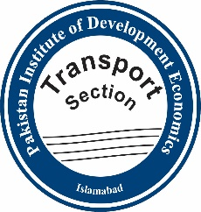
Revised on
23-01-2023 Dated: ______________
STAFF VEHICLE REQUISITION

1. | Name (In block letters)
2. | Designation
3. | Other staff members to travel (if any)
4. | Purpose |  | Official  (specify)
Project
(Name)
5. | Places to be visited
6. | Date of travel |  | Time: From To:

Signature of Applicant

Head of Division/Department/Section

Registrar

Assistant Registrar (Transport)

1.  2.  3.  4. | During office hours, the requisition must be submitted Two Hours before the travel time.  For late sitting, the requisition must be submitted Two Hours before the closing hours.  The vehicle will be provided for journey to residence at least Two Hours beyond the normal working hours.  *Only approved requisitions will be entertained (in case of Research Staff, the relevant Division Head, Teaching Staff, the Dean of Faculty and Administration Staff, the Vice Chancellor, PIDE will approve the requisition).

