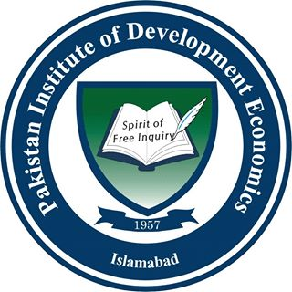 | Pakistan Institute of Development Economics, Islamabad

Alumni Survey
PROFORMA - 7
(To be filled by Alumni - after the completion of each academic year)
The purpose of this survey is to obtain alumni input on the quality of education they received and the level of preparation they had at University. The purpose of this survey is to assess the quality of the academic program. We seek your help in completing this survey.

A: Excellent B: Very good C: Good D: Fair E: Poor

- Knowledge
- Problem formulation and solving skills | A | B | C | D | E
- Collecting and analyzing appropriate data | A | B | C | D | E
- Ability to link theory to practice. | A | B | C | D | E
- IT knowledge | A | B | C | D | E
- Communication Skills
- Oral communication | A | B | C | D | E
- Report writing | A | B | C | D | E
- Presentation skills | A | B | C | D | E
- Interpersonal Skills
- Ability to work in teams. | A  A | B | C | D | E
- Ability to work in arduous /Challenging situation | A  A | B | C | D | E
- Independent thinking | A | B | C | D | E
- Appreciation of ethical Value | A | B | C | D | E
- Management / Leadership Skills
- Resource and Time management skills | A | B | C | D | E
- Judgment | A | B | C | D | E
- Discipline | A | B | C | D | E

- General Comments: Please make any additional comments or suggestions, which you think would help strengthen our programs. (New courses that you would recommend and courses that you did not gain much from)
Comment Box

- Career Opportunities:
Comment Box

A: Excellent B: Very good C: Good D: Fair E: Poor
- Department Status
- Infrastructure | A | B | C | D | E
- Faculty | A | B | C | D | E
- Repute at National level | A | B | C | D | E
- Repute at international level | A | B | C | D | E

- Alumni Information
Text Box
Text Box
Text Box
Text Box
- Name (Optional)
- Name of organization
- Position in organization
- Year of graduation

